Date | Particulars | LF | Debit [Dr.]  Amount | Credit[Cr.]  Amount
JOURNAL FORMAT

Books of-----------------------------------------

How is input tax credits adjusted?Offset liability in GST
Let us consider that goods worth Rs. 10,000 are sold by manufacturer A from Maharashtra to Dealer B in Maharashtra.
Dealer B resells them to Trader C in Rajasthan for Rs. 17,500.
Trader C finally sells to end user D in Rajasthan for Rs. 30,000.
Suppose the applicable tax rates for the goods sold are CGST= 9%, SGST=9%, and IGST=9+9=18%
Since A is selling this to B in Maharashtra itself, it is an intra-state sale and so, CGST@9% and SGST@9% will apply.
Dealer B (Maharashtra) is selling to Trader C (Rajasthan). Hence, this is an interstate sale, with IGST@18%.
Trader C (Rajasthan) is selling to end user D also in Rajasthan. Once again it is an intra-state sale and hence, CGST@9% and SGST@9% will apply.
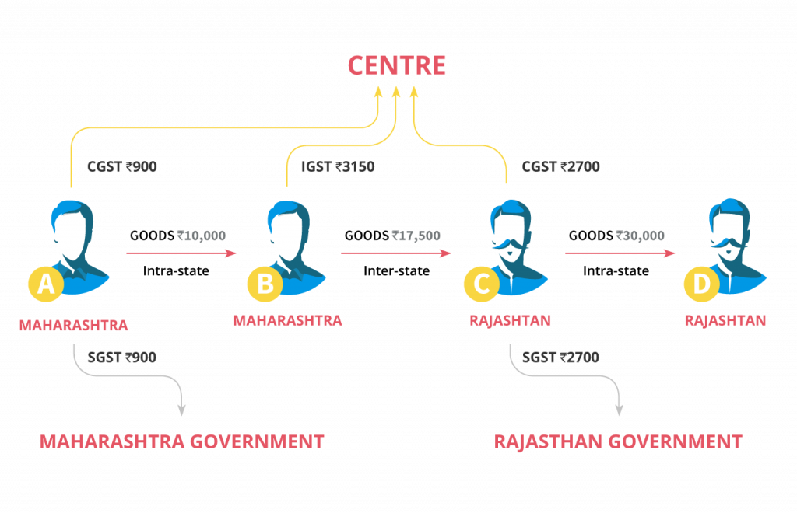
Pass entries in the books of Mukerjee & Sons. assuming all transactions have taken place within the state of Uttar Pradesh. Assume CGST @9% and SGST @ 9%.
2018
March 1 | Purchased goods for ₹ 5,00,000 from Mehta Bros.
March 10 | Sold goods for ₹ 8,00,000 to Munjal & Co.
March 15 | Paid for advertisement ₹ 40,000 by cheque.
March 18 | Purchased furniture for office use ₹ 50,000 and payment made by cheque.
March 25 | Paid for printing and stationery ₹ 8,000.
March 31 | Payment made of balance amount of GST.
Pass entries in the books of Devdhar & Bros. Odisha, assuming all transactions have been entered within the state, charging CGST and SGST @ 9% each:
2018
March 4 | Purchased goods for ₹ 5,00,000 from Sunil Bros.
7 | Goods returned to Sunil Bros. for ₹ 20,000
10 | Sold goods to Mehta & Co. for ₹ 8,00,000
12 | Goods returned by Mehta & Co. for ₹ 30,000
20 | Goods withdrawn by Proprietor for personal use ₹ 10,000
25 | Goods distributed as free samples ₹ 5,000
26 | Paid advertisement expenses by cheque ₹ 20,000
31 | Payment made of balance amount of GST.

